Adaptation Projects – What Would Work for Your Community?
- A Community Raingarden Project.
Convert an area of waste ground into a raingarden, which can help to prevent localised flooding, and brighten up your neighbourhood. You can involve all sorts of local groups in planning and delivering the project. We can support you by matching you up with technical expertise from a University or College who can provide engineering and design support. Decide what to grow and how you would like your raingarden to be decorated. Consider how this project might lead to other climate adaptation interventions in your local area.
How much?
A project like this could cost anywhere from £2500 to £5000 depending on its complexity.
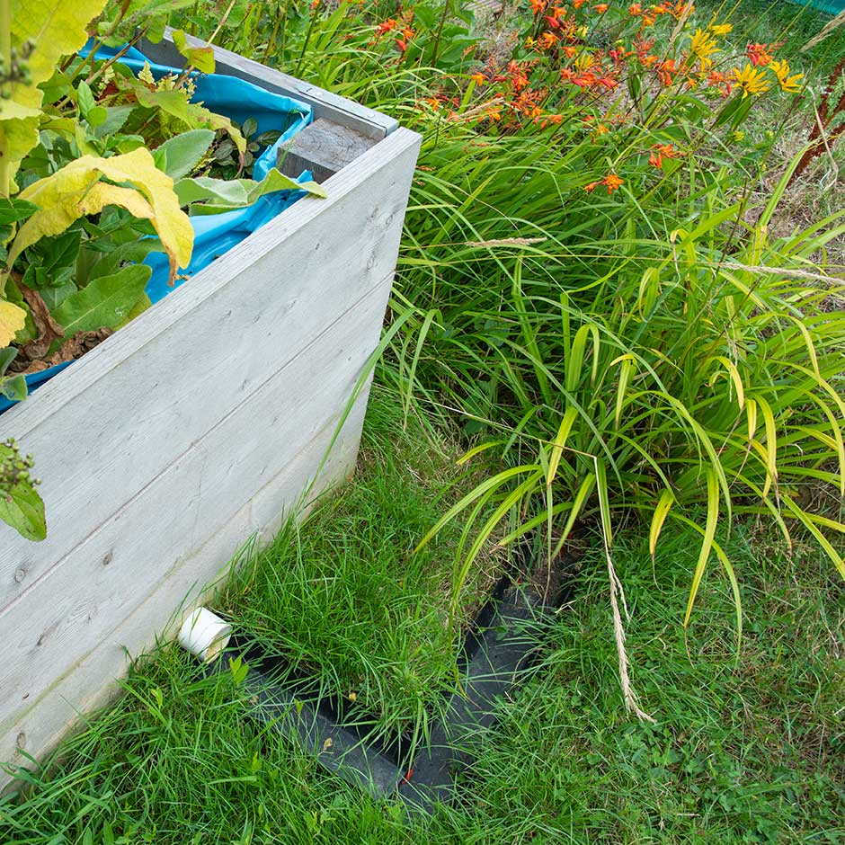

- A Community Garden or Orchard Project
This could be another great way of brightening up your community while making it more resilient to climate change and the cost of living. However, if planned properly, it will require regular maintenance and almost certainly a group of volunteers. You would need to identify a suitable piece of land, and decide what would be best to grow on it – we can bring in expertise from other similar projects to help with this. You will need to decide how the garden can be maintained, to ensure it is seen as a true community asset. This might mean employing a part time gardener, or tapping into local volunteers who might be keen to help. This project could lead to bigger things, such as the formation of a community action group or the establishment of a larger community hub, all of which can contribute to greater resilience against the climate crisis.
How much?
A project like this might cost anywhere between £7000 to £10,000 to deliver properly.
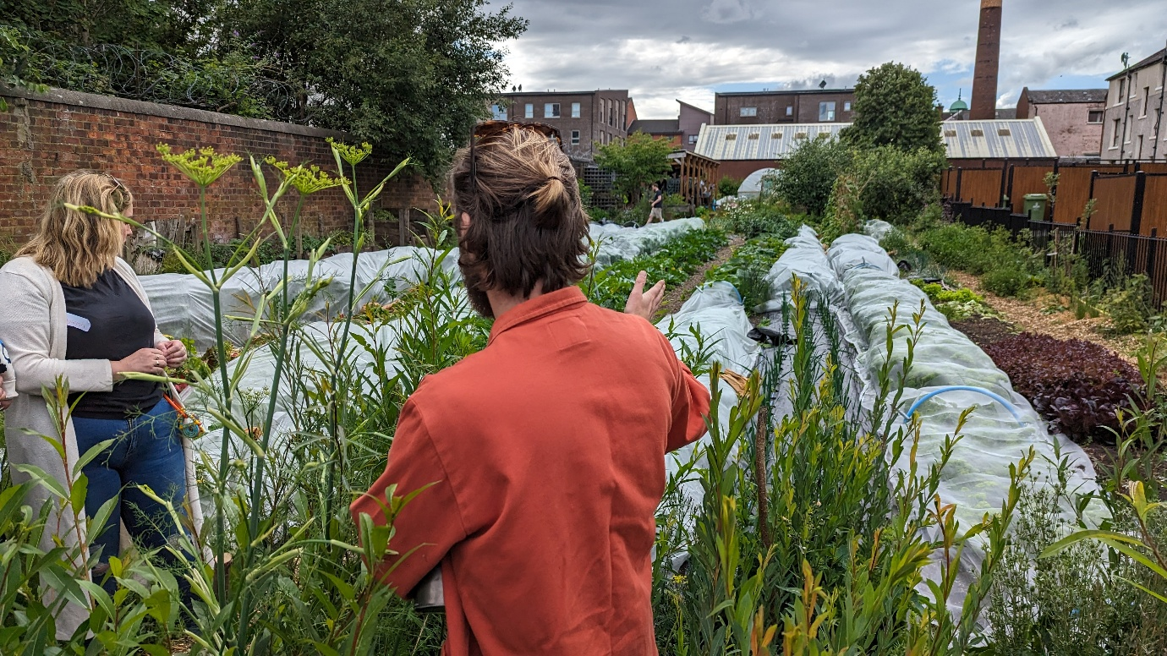

- A Community Hub offering support and opportunity for local people.
This type of project could take many forms. The most common might be a group of local people coming together to offer support to their neighbourhood, through some kind of fixed asset. This could be a building which isn’t used as regularly as it once was, or a “nomadic” group which pops up in different spaces over time. There would be issues to consider here around governance, banking, safety and safeguarding, insurance, and many more – though we can offer support, and connections to existing similar organisations. As our communities adapt to climate change, we will need to be agile in our responses that we offer. A group like this could run lunch clubs, after school activities, resources for new mums, opportunities for people on low incomes, and so much more. It could also act as a catalyst for future activity, giving people a banner to come together under. This might make future funding bids more likely. It would be a complex project which would need a lot of support but which could ultimately have a long lasting impact.
How much?
We would imagine that a budget of around £15,000 might allow an organisation to kick start a project like this.
